Bryan Vuong

BUS4-112

Professor Ashraf Shirani

11/20/2020

Screenshot pt.1

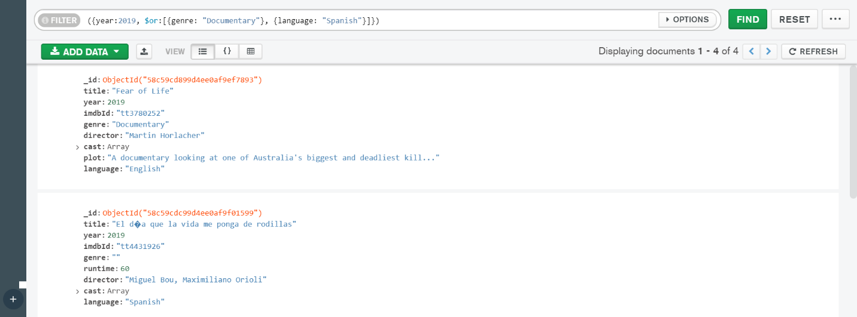

Screenshot pt.2

